- Purpose

The purpose of this document is to describe the specifications and design that will be implemented for the process of resubmitting existing images for analysis.

- General Requirements

All services should be contained in try/catch blocks and any exceptions should be logged using the standard logging process.

- Specifications

Requirement #1: A new button should be added to the view capture dialog to allow the image analysis to be rerun using the current algorithm implemented in the Analysis Functions.

Specification: A button labeled “Resubmit Images for Analysis” will be added to the bottom of the View Capture dialog. Clicking this button will perform the following actions:
- Create a new treatment Id for the subject whose results are being viewed.
- Save a copy of the images in the database using the new Treatment Id as the key. The angles entered by the user as well as the midpoint coordinates will also be saved.
- Perform the analysis function and write the results to new rows in the AnalysisResults and Severity tables.
- Display the new result pages to the user

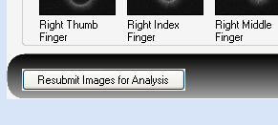

Requirement #2: The resubmit button will only be available to the user ‘administrator’

Specification: When the page is rendered, the currently logged in id of the user will be queried to determine it is ‘administrator’. If a positive identification is made, the button will be displayed, otherwise it will remain invisible.

Requirement #3: If finger images are available, display them, otherwise show a blank window.

Specification: Finger images will be displayed next to the energized image when available. If no image is available, a placeholder image will probably be used rather than a blank image. The placeholder image will state that an image is not available.

Requirement #4: Display angle and center point; Angles and center points can be changes and the modifications will be used in the new analysis.

Specification: For each image selected, display the X and Y center coordinates as well as the orientation angle that was stored for the original image. The user will be allowed to adjust the angle of the image as well as the center point. If changes are made, the new values will be submitted to the engine when the calculations are run.

Requirement #5: A new report and treatment Id should be created when the images are resubmitted through the system.

Specification: By design a new treatment id will be created at the time of resubmission. The resubmission has not link to the original data other than a text note which will be described later. The original data is not changed in any way; the new submission is simply a copy of the original data with the changes made by the user (if any). Both the original run as well as the resubmitted run will be available to the user during a search.

Requirement #6: Save the version of the software used to create the analysis result, this should be stored in the raw data table.

Specification: The version of the software used to create the raw data will now be stamped into the raw data table. The raw data table ‘AnalysisResults’ will contain the version of the software at the time the calculations were run.
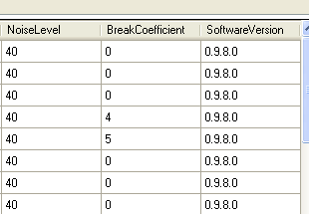
All old data in the system will contain the text –Unknown- in the version data column. This is necessary because we have no way of determining the exact version of software that the calculations were created with.

Requirement #7: Add version number to the capture search results page.

Specification: The version of the software used to create the results will be displayed on the search results window.
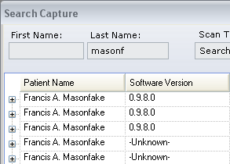

Requirement #7: Remove both Capture Id and Patient Id from the search results.

Specification: The two columns specified above (Capture Id and Patient Id) will be removed from the search results dialog. The data will remain in the database, but they will not appear in the dialog.
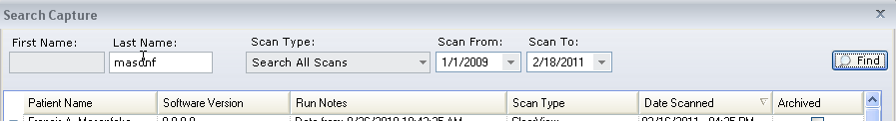

Requirement #8: Change the capture search dialog drop down to read “Search all Scans” rather than “Search All Treatment Types”

Specification: The wording in the drop down will be changed to reflect the requested values.
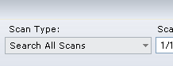

Requirement #9: Denote the new run as a re-run (possibly reference original data).

Specification: A new column will be added to the capture search dialog to denote if it is an original run, or a re-run. If the run is an original (full scan) run, the verbiage in the column will be:
Initial run of data
If the run is a resubmission, the text will be:
Data from: {date and time of run}
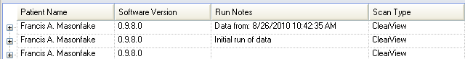

Requirement #10: When the data is re-run it should be treated as an independent scan, a new treatment ID should be assigned and new results should be stored separate from the original results.

Specification: This is somewhat a duplicate of #5. By design a new treatment id will be created at the time of resubmission. The resubmission has not link to the original data other than a text note which will be described later. The original data is not changed in any way; the new submission is simply a copy of the original data with the changes made by the user (if any). Both the original run as well as the resubmitted run will be available to the user during a search.

Document Revision History
Version Number: | Description of Change: | Date: | Updated by:
000 | Introduction | 5/24/11 | A. Mason

